

 Wallet Walkthrough – Hands-on Wallet Setup  
  
**Objective/Aim:**  
  
 To study and understand about wallet creation.

**Apparatus/Software Used:**

* Laptop/PC
* PowerPoint/Word for documentation
* Internet for research

**Theory/Concept:**

1. A MetaMask wallet ID is your public address, a unique string of characters (usually starting with "0x...") that identifies your account on the Ethereum blockchain.
2. This address is used to send and receive funds and interact with decentralized applications (dApps).

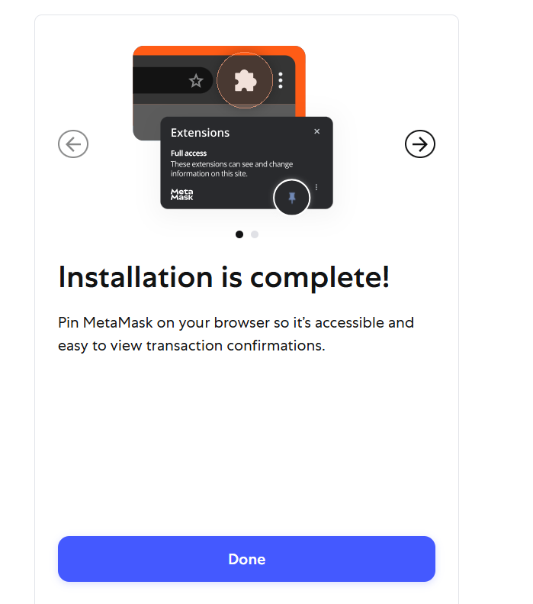

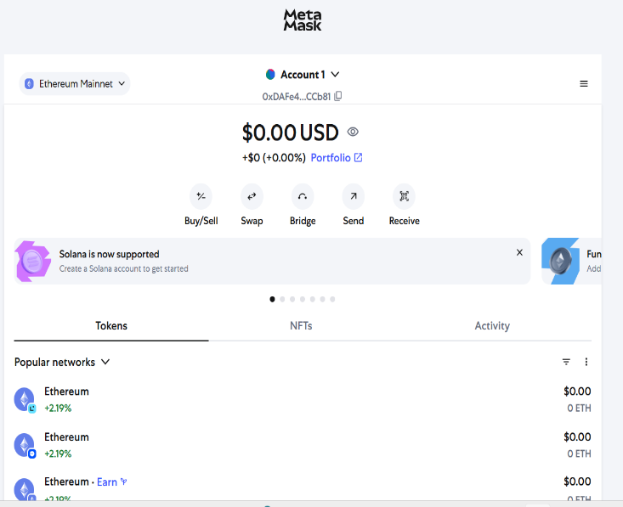

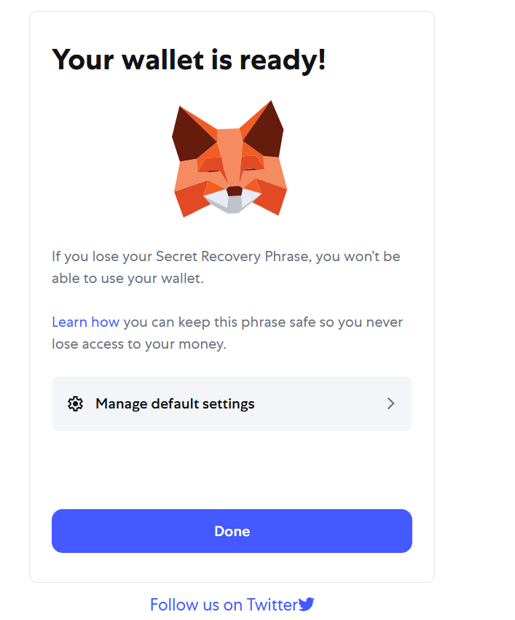

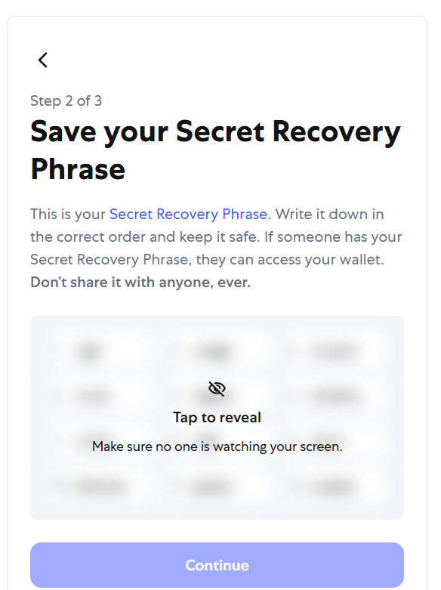

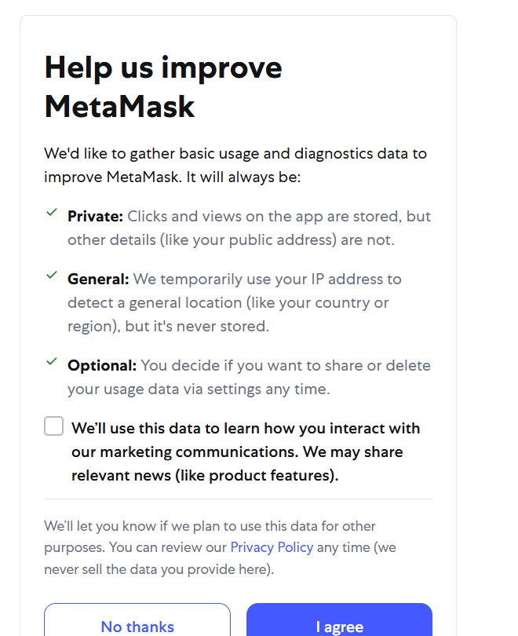

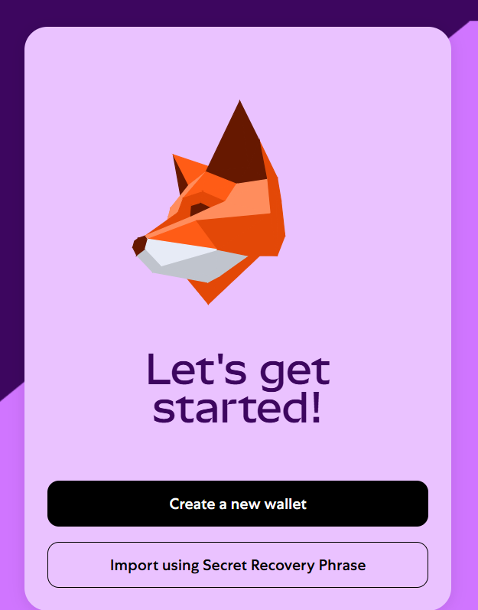



**Procedure:**

|  |  |  |  |
| --- | --- | --- | --- |
|  |  |  |  |
|  |  |  |  |
|  |  |  |  |
|  |  |  |  |
|  |  |  |  |
|  |  |  |  |
|  |  |  |  |

Here's how to find your MetaMask wallet ID (public address):

1. **Open MetaMask:** Launch the MetaMask extension or mobile app.
2. **Locate the Account:** Your public address is displayed beneath the account name.
3. **Copy the Address:** Click on the address to copy it to your clipboard.

**Observation Table:**

| **2**. Without recovery phase you cannot access your wallet. |  |  |
| --- | --- | --- |
|  |  |  |
|  |  |  |
|  |  |  |
|  |  |  |
|  |  |  |
|  |  |  |
|  |  |  |
|  |  |  |
|  |  |  |
|  |  |  |
|  |  |  |
|  |  |  |

1. Don’t share your wallet address with anyone.



